**NOS-120 Chapter 6**

Log into NDG and workstation virtual Classroom Machine to complete this quiz.

1. Type **grep wheel /etc/group**. What is the group id number for wheel and also list the users in that group.

**Group ID – 10**

**Users - Student**

Insert Screenshot Below:

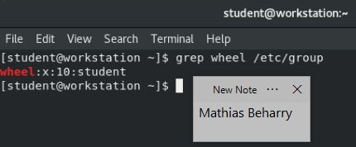

1. Type the command to create a new group named **quiz3**. After you have created this group run **grep quiz3 /etc/group** to verify the group was created.

Insert Screenshot Below:

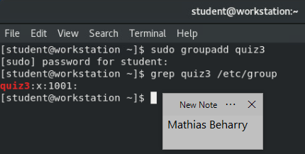

1. Type the command with the appropriate option to create a new user named Tom with quiz3 as the supplementary group for the user. After you have created the user run **id Tom.**

Insert Screenshot Below:

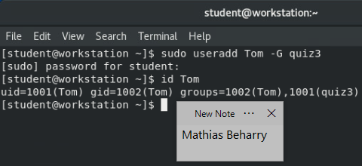

1. Type the command with the appropriate option to set the user Tom’s account to expire on July 4th, 2020. Run **chage -l Tom** to verify the change.

Insert Screenshot Below:

